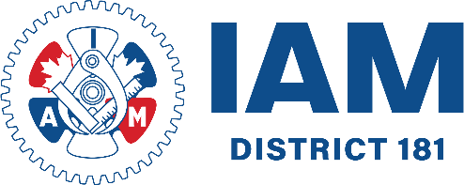

IAM UNION | DISTRICT 181
203-1311 Portage Avenue
Winnipeg MB
R3G 0V2
iamdl181.org



