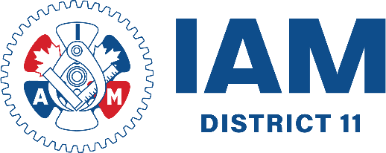

IAM UNION | DISTRICT 11
5255 boul Henri-Bourassa Ouest Office 102
Saint-Laurent QC
H4R 2M6
TEL: 514.956.1578
aimtadistrict11.org



