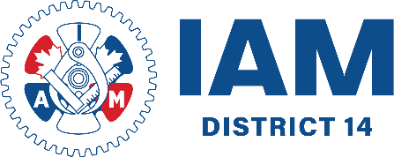

IAM UNION | DISTRICT 14
107, 10471 – 178 Street NW
Edmonton, Alberta
T5R 1R5 - CANADA
TEL: 780.414.1499
iamdl14.org

