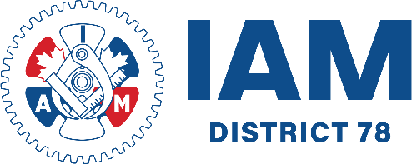

IAM UNION | DISTRICT 78
557 Dixon Road, Unit 102
Toronto, Ontario
M9W 6K1
TEL: 416.225.9003
iamdl78.org



